CHAPTER 6
FRONT-END AND BACK-END CODE OF CLASSROOM & LAB UTILIZATION OPTIMIZATION SYSTEM

6.1 Front-End Module codes

The front-end of the application is built using React and TypeScript. Below is the main application routing file (`App.tsx`) which handles protected routes, context integration, and navigation logic.

src/App.tsx:

import { Routes, Route, Navigate } from 'react-router-dom';
import { useAuth } from './contexts/AuthContext';
import LandingPage from './components/LandingPage';
import AuthPage from './components/auth/AuthPage';
import DashboardLayout from './components/DashboardLayout';

function ProtectedRoute({ children }: { children: React.ReactNode }) {
const { isAuthenticated, loading } = useAuth();
if (loading) {
return (
<div className="min-h-screen flex items-center justify-center bg-gray-50">
<div className="flex items-center gap-3">
<div className="w-8 h-8 border-3 border-blue-200 border-t-blue-600 rounded-full animate-spin" />
<span className="text-gray-500 font-medium">Loading...</span>
</div>
</div>
);
}
return isAuthenticated ? <>{children}</> : <Navigate to="/auth" replace />;
}

function App() {
return (
<Routes>
<Route path="/" element={<LandingPage />} />
<Route path="/auth" element={<AuthPage />} />
<Route
path="/app/*"
element={
<ProtectedRoute>
<DashboardLayout />
</ProtectedRoute>
}
/>
<Route path="*" element={<Navigate to="/" replace />} />
</Routes>
);
}

export default App;

6.2 Database connectivity

The back-end server connects to the MySQL database using the `mysql2` promise-based API. A connection pool is established to manage concurrent database queries, transactions, and row-level locking efficiently.

server/db.js:

import { createPool } from 'mysql2/promise';
import dotenv from 'dotenv';
import path from 'path';
import { fileURLToPath } from 'url';

const __dirname = path.dirname(fileURLToPath(import.meta.url));
dotenv.config({ path: path.join(__dirname, '.env') });

// Ensure your .env file in the server/ directory contains these variables:
// DB_HOST, DB_USER, DB_PASSWORD, DB_NAME (default: classroom_utilization_db)
const pool = createPool({
host: process.env.DB_HOST || 'localhost',
user: process.env.DB_USER || 'root',
password: process.env.DB_PASSWORD || '',
database: process.env.DB_NAME || 'classroom_utilization_db',
waitForConnections: true,
connectionLimit: 10,
queueLimit: 0
});

export default pool;

CHAPTER 7
RESULTS AND DISCUSSIONS

7.1 Screenshots of front-end

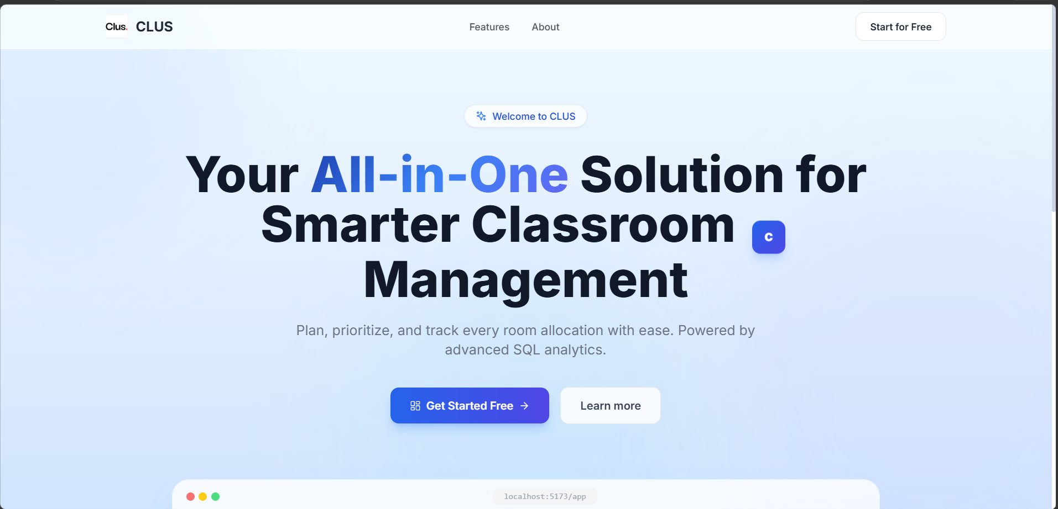Chapter 7. Figure 7.1: Landing Page of the Application

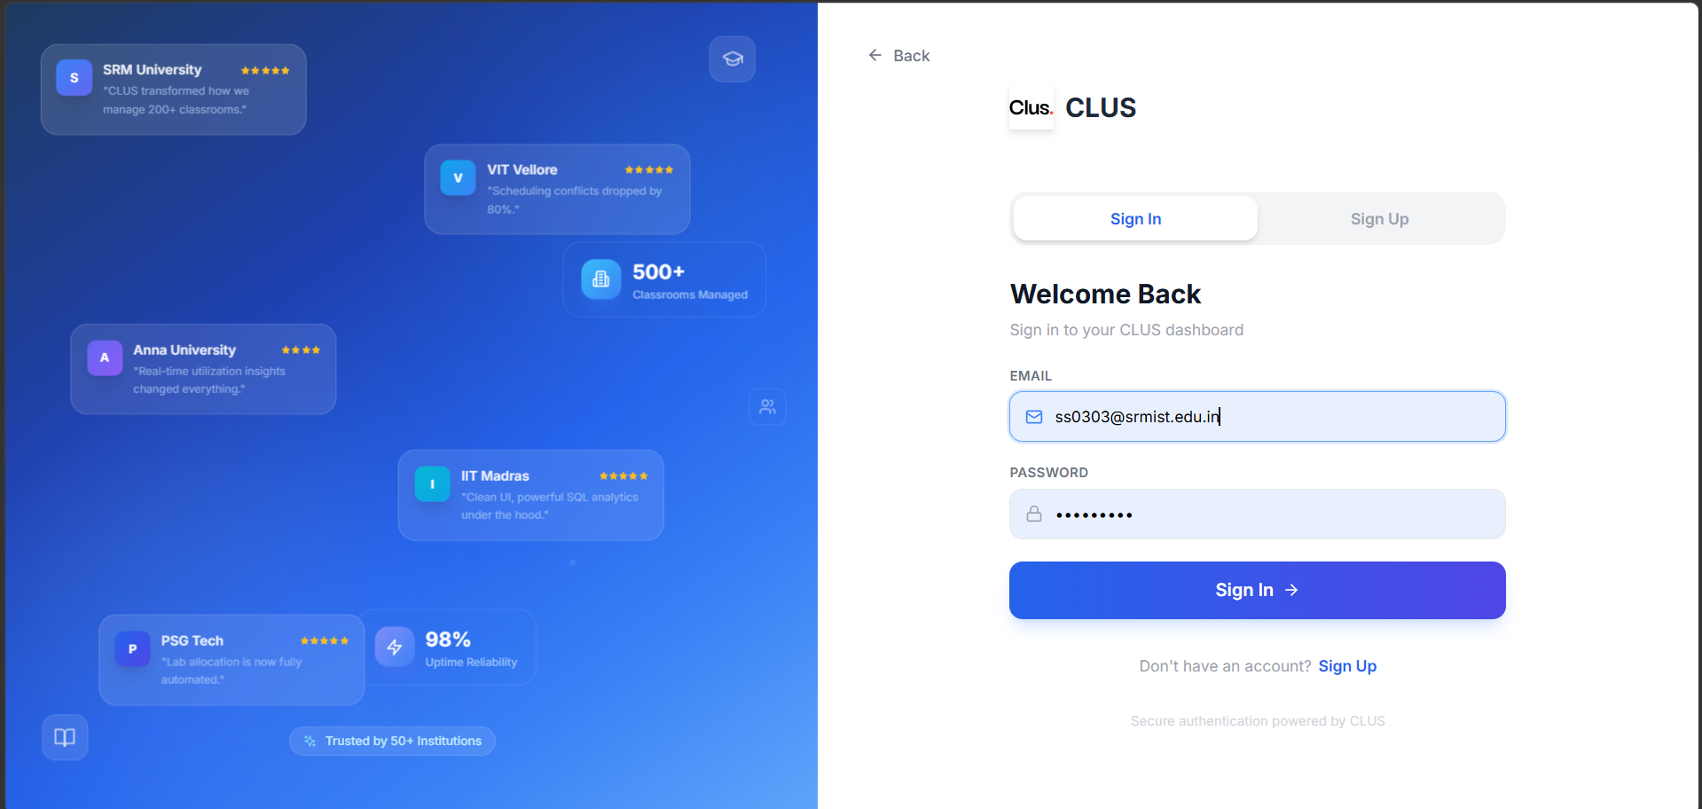Chapter 7. Figure 7.2: User Authentication Interface

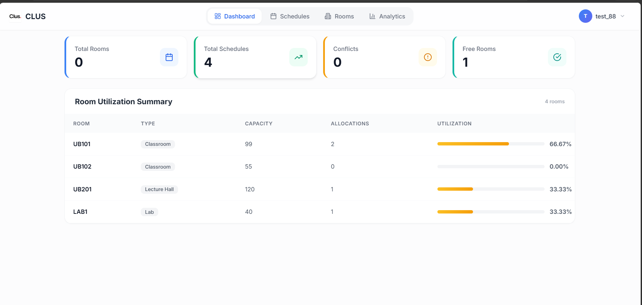
Chapter 7. Figure 7.3: Main Dashboard showing Room Allocations and Utilization metrics

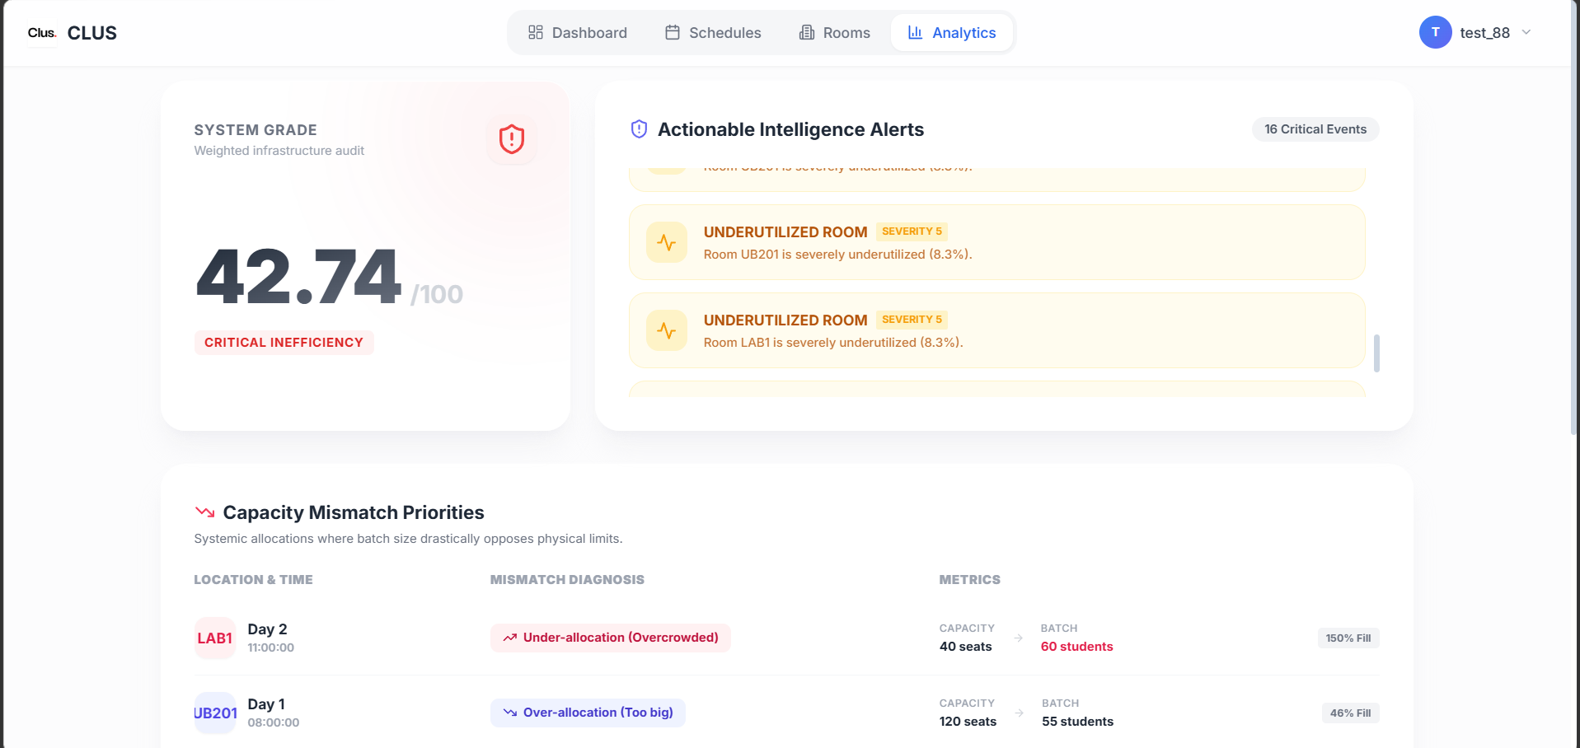Chapter 7. Figure 7.4: Analytics tab showing course load and room saturation data

7.2 Screenshots of Database

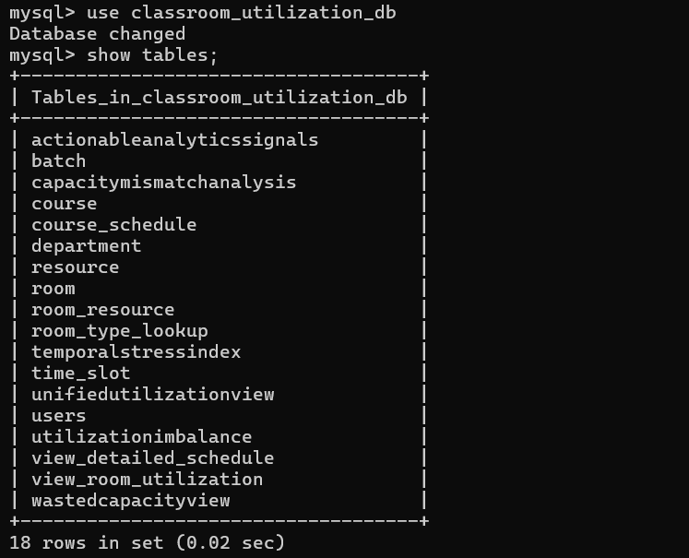Chapter 7. Figure 7.5: Database Tables in MySQL

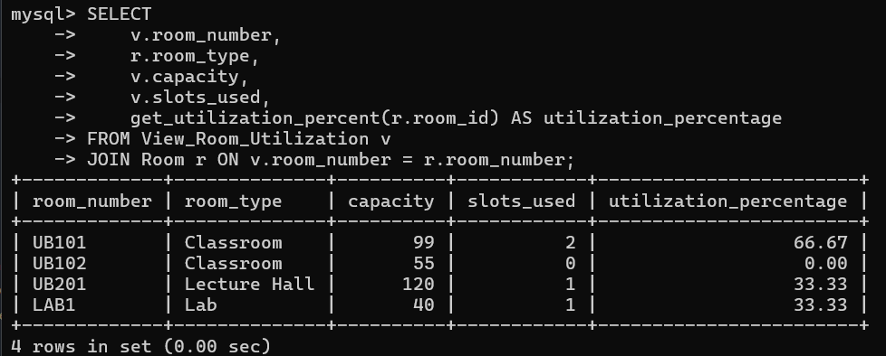Chapter 7. Figure 7.6: Results of Utilization Percentage View

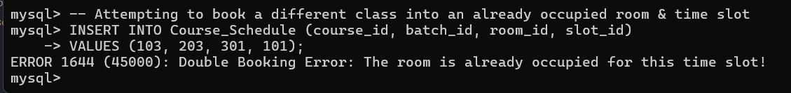Chapter 7. Figure 7.7: Trigger Execution preventing double-booking

References

[1] R. Elmasri and S. B. Navathe, Fundamentals of Database Systems, 7th ed. Pearson, 2015.
[2] A. Silberschatz, H. F. Korth, and S. Sudarshan, Database System Concepts, 7th ed. McGraw-Hill Education, 2019.
[3] "MySQL 8.0 Reference Manual," Oracle Corporation. [Online]. Available: https://dev.mysql.com/doc/refman/8.0/en/. [Accessed: May 2026].
[4] "React Documentation," Meta Platforms, Inc. [Online]. Available: https://reactjs.org/docs/getting-started.html. [Accessed: May 2026].
[5] "Express Node.js web application framework," OpenJS Foundation. [Online]. Available: https://expressjs.com/. [Accessed: May 2026].

